**Interaction variables**

Interaction variables is nothing but interacting two or more variables to create new features

Here We take a similar task as we take in binning

In below image there is an example of logical 2 way interaction feature because here we are interacting 2 features using logical AND operator and thus creates new feature f1

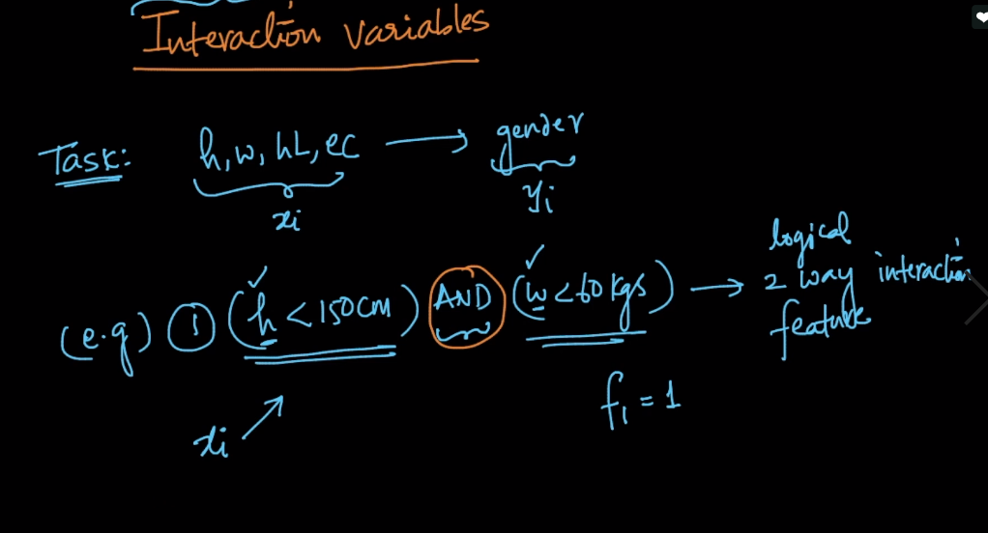

Ex2 : is a math 2-way interaction features. We can use any mathematical operator

Ex3 : is a logical 3-way interaction feature because we are using 3 features

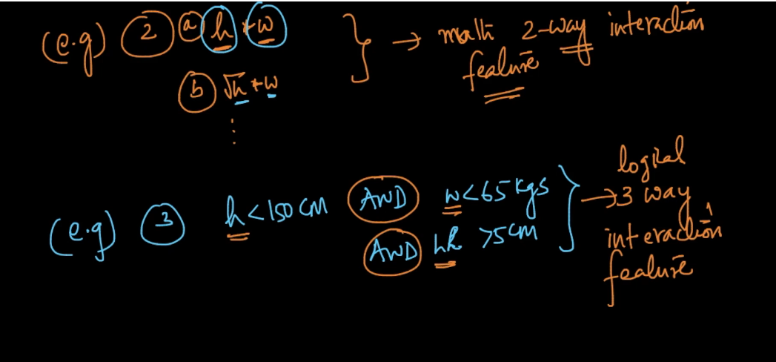

So question is how to find good interaction features.

Solution of this is same as binning we use decision tree but here we use on whole dataset i.e on all features instead of single feature

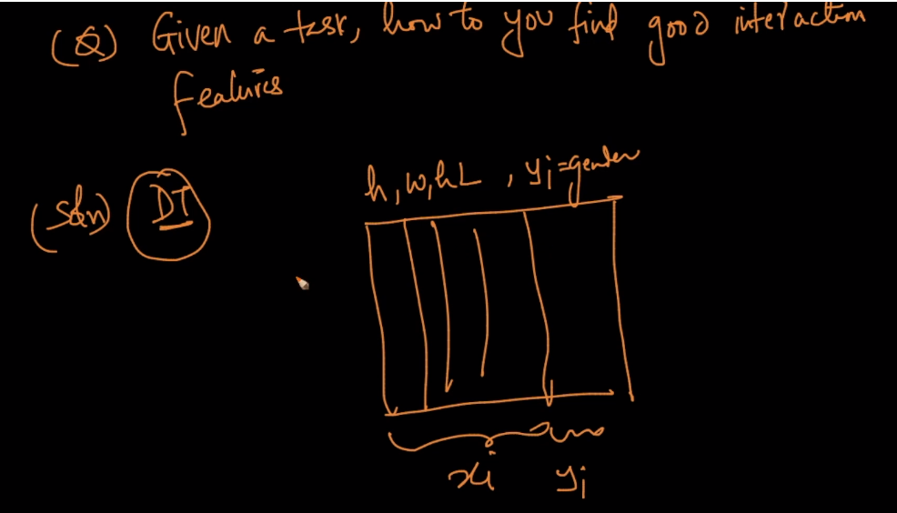

And thus we create a new feature according to a condition given by DT as shown in below figure.

And it surely work well because we DT to predict yi using IG or gini impurity

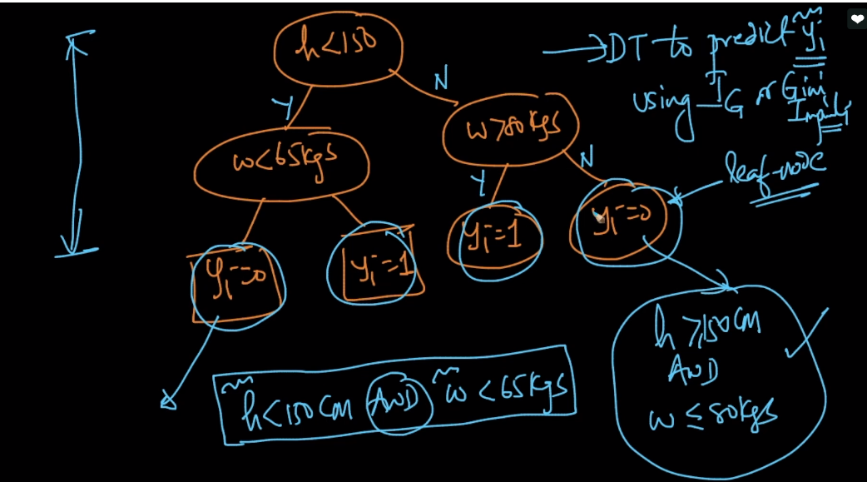

So again we saw that DT method is also use to perform feature engineering

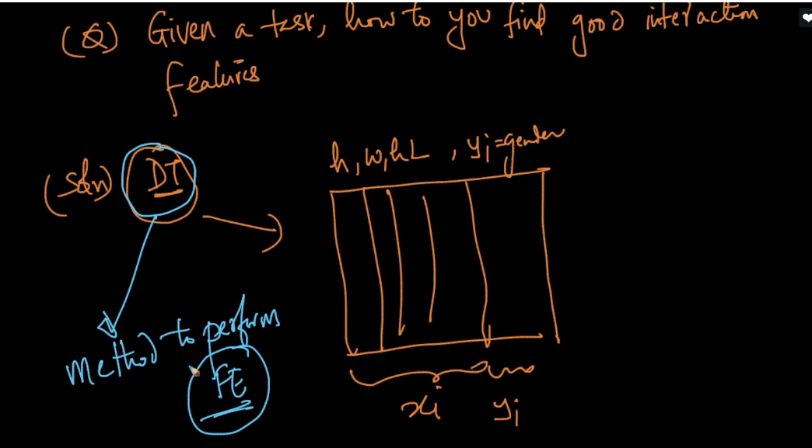

Comments:

